**Cost Analysis Report**

1. **Cost breakdown for each month:**

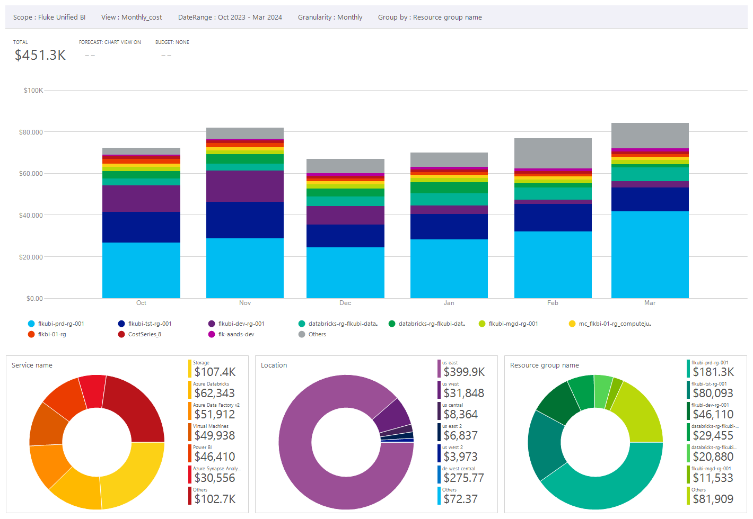

Link to access this chart:

https://portal.azure.com#@fortive.onmicrosoft.com/blade/Microsoft_Azure_CostManagement/Menu/open/CostAnalysis/scope/%2Fsubscriptions%2F52a1d076-bbbf-422a-9bf7-95d61247be4b/view/H4sIAAAAAAAAA41Sy27bMBD8F57ltDEcG8nNj9QIkEqB5fRSBMaKXClEJFLlI6hh6N%2B7K9mt3Uty5O7McGZ3D0JG59DIvbgTz%2FlKJEJBwA2YCqnyCD5Mv1sTXj11fkV0hDuIsG%2B5O5chQr20Pgw0yDFwu3JgYg1OB1bt6fWeIFBVDisI2ppexYYjmx4GGpY8ipXRyAEm8tiILvkHZpOX%2BMH2%2FxTieOuCNpW4%2B3kQSjs89cFLNIo7yUlnoeuaCr1X0b0klMHG9kQ%2B5l3pBo1njb%2B8DXobncQ1w1OudS%2FslpClGyCpNcgJ5Cu4wO4CyDdUS1vHhpVAytjQuAIq6pZQe6Rqq99t8B%2F8nqN71xKHf5PP%2BHy0cpj%2F5%2BDnsWie0vYEHwsvnW5ZyH%2B5GcO1%2BjqbjoqiKEeT8RhGt0U5G93eqOn1eDIrcFKQ8lurL%2BIsoqqQd6059jLLt7t0%2FuNhPd9mm6vF82p9v91lT9uHLM2v0iy9JyQaKGqeUnAR6fk70BpRPTmyRZtGf34YHwt2ZzP4Zuk8oL%2B9i184ttK%2BrWGfDsLHc95JvtTuD9ARThZAAwAA

1. **Cost Breakdown on Azure services:**

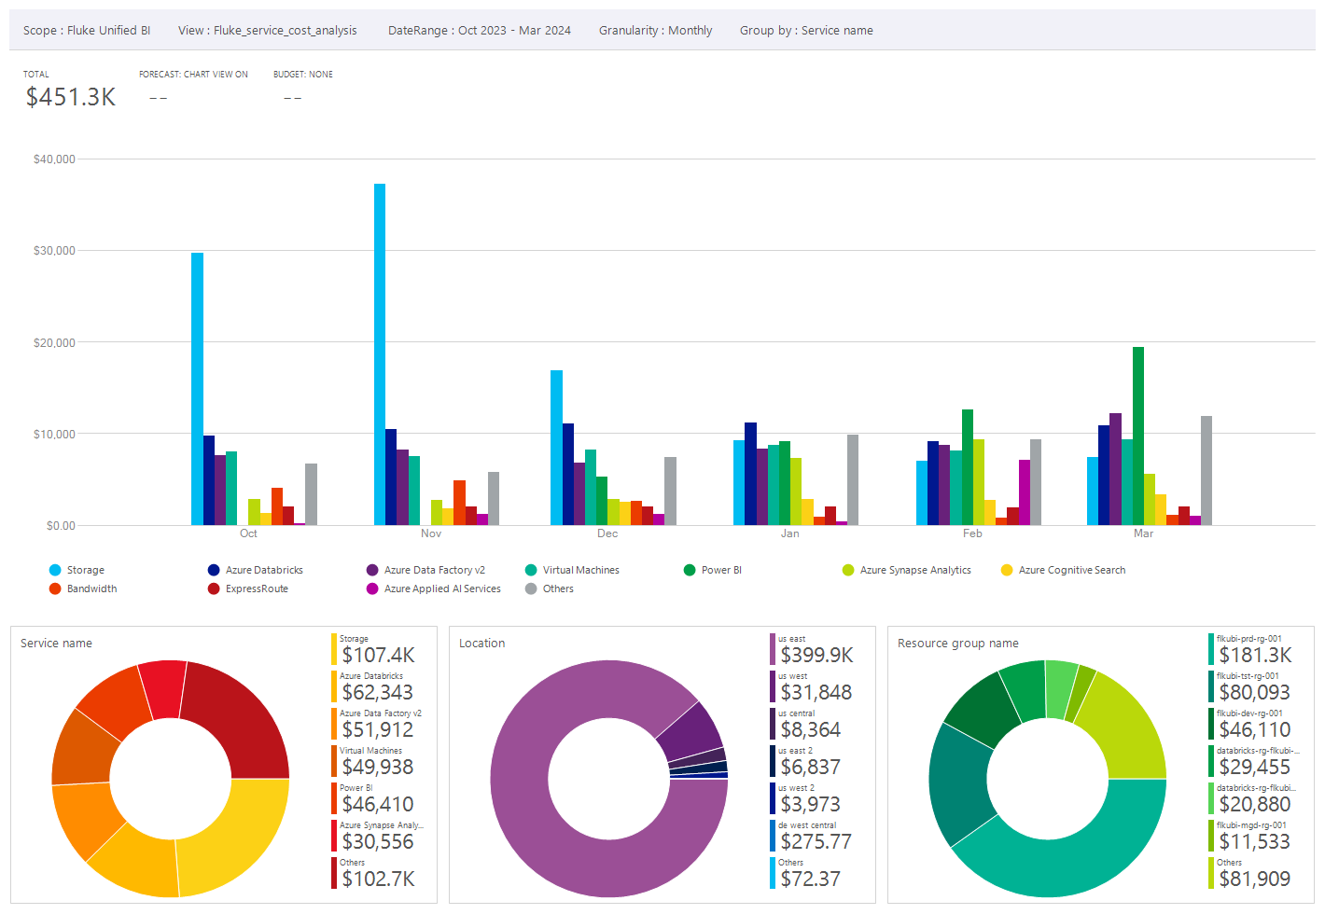

Link to access this chart : https://portal.azure.com#@fortive.onmicrosoft.com/blade/Microsoft_Azure_CostManagement/Menu/open/CostAnalysis/scope/%2Fsubscriptions%2F52a1d076-bbbf-422a-9bf7-95d61247be4b/view/H4sIAAAAAAAAA5VSyW7bMBD9F57ltDEcG8nNS2IESKXAcnIpAmFEjhQiFKlyCSoY%2BvcOJbuNe%2BhyJN%2FC94ZzYDxYi5p37IY95RuWMAEed6BrpJsHcH7%2BxWj%2F6gj5FtAS78B810Z0yX0AtTbOjzLI0Ue4tqCDAit9dB3kqiMK1LXFGrw0enAx%2Fqimg4YmWh7NqqD5SGN5aFif%2FCLHkOf8MfbvEtI4Y73UNbv5emBCWjzh4DhqEZHk5LOSStHFkJX1Lwl1MKE9iY99N7JB7aLHT12O9l1yTOOpf4k5iVPZEUyNxpidv4KlkmwbPVGsjQpN9ADOQ0OD8igIrUA5pNtWvhvv%2Fufd5E%2FMHToTLMcHw8fJ%2Fxt9yHqsRZPkZhC4UDpuZRuN3KerKVyKz4v5pCzLajKbTmFyXVaLyfWVmF9OZ4sSZyU5v7XyrM4qiBrjL8tYe53l%2ByJdPt9vl%2Ftsd7F62mxv90X2uL%2FP0vwizdJbYqKGUsUpeRuQjt89fSCKR0ux6I%2FRfVyJvxv2H2ZwZ2gxYNi6s1dibSFdq6BLR%2BM7Fd6wcOPkC06bV4AG1Tmq1%2F8AENhklkkDAAA%3D

1. **Cost breakdown for storage account on Resource groups:**

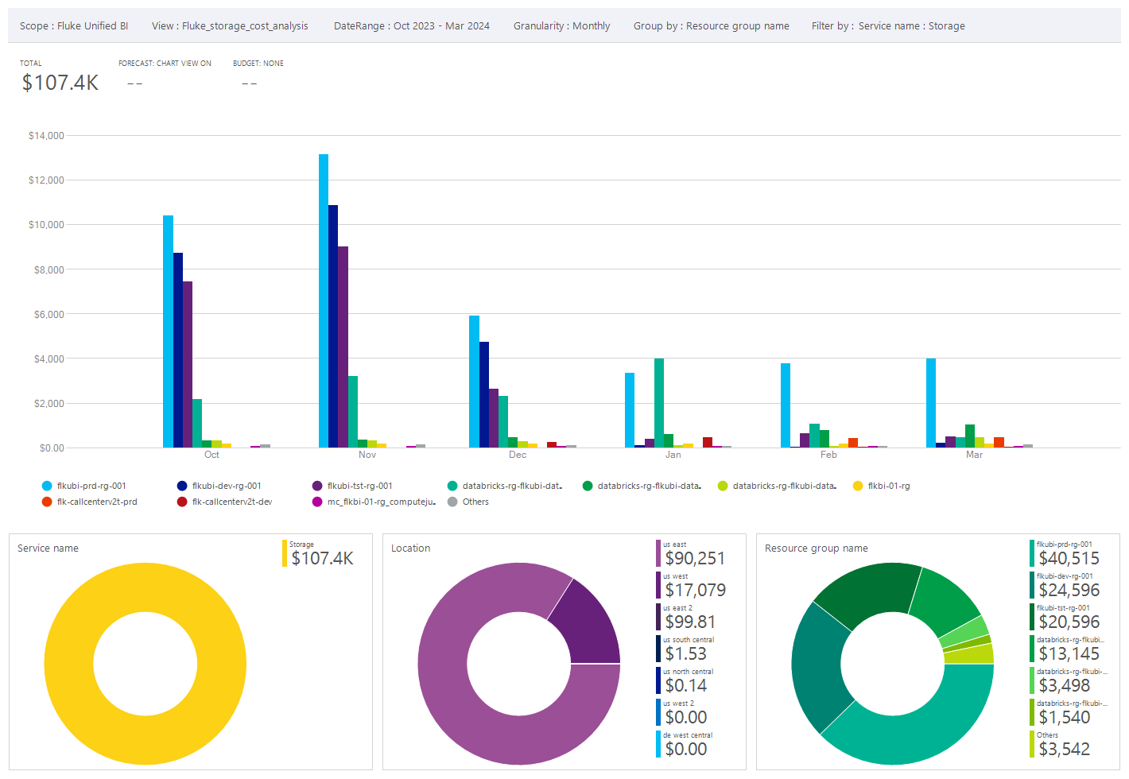

Link to access the chart : https://portal.azure.com#@fortive.onmicrosoft.com/blade/Microsoft_Azure_CostManagement/Menu/open/CostAnalysis/scope/%2Fsubscriptions%2F52a1d076-bbbf-422a-9bf7-95d61247be4b/view/H4sIAAAAAAAAA41SXU%2FjMBD8L35OuaMqreCNtlBV4hLUFF4QqjbOJli4ds4f6Koq%2F%2F12k5Zr7wUevTsz3tmdvZDROTRyJ27EUz4XiSgh4ApMjVR5AB%2FGv6wJb546vyM6wu1F2DXcvZUhgp5ZH3oa5Bi4XTswUYNTgVU7ut4RBOraYQ1BWdOp2HBg08PAliUPYlU0soeJPG5Fm%2FwD85Dn%2BH7s%2FynE8dYFZWpx87IXpXJ47IOXaEruJEedqdKaCt2son1NyIONzZF88DtXWzSeNT55K%2FQ2OokLhqdcY3KldEDHY35SPL%2FSnpSj%2B1ASu1cisgYdBEtwsWTlZ9ARCf4icqoC3eG1ZTeBpCrXK6TWIG9FvoGj9YnueyxnVscta4CUcUsnCFhStwLt%2BadGfdjgv3B0OlybfMf7g5X9Tb8HP1%2BVl7Yj%2BFh46VTDQv7H1RAuy5%2BT8aAoimowGg5hcF1Uk8H1VTm%2BHI4mBY4KUn5v1JmdaSxr5Pwotj3L8vUmvX1eLm7X2epi%2BjRf3K032eN6maX5RZqld4REA4XmLQUXkZ5%2FAkUDy0dHY1F60J%2BG7WvB9mQH95YiB12ez35h26XyjYbdIRD3Or7jxvfn3kjK9AYM6J0ne%2B1fYsNcK6MDAAA%3D